

# Computer & Electronic Engineering

# Final Year Project "Music Host Interface"

# Sprint 8: Week 3 Log

# Thomas Flynn

# Project Supervisor: Brian O'Shea

# 18/04/16 - 24/04/16

# 1 Log Entries

## 1.1.0 Entry 1: 18/03/16

Today I worked on UML diagrams.

## 1.1.0 Entry 2: 19/03/16

Today I worked on UML diagrams and tweaked my FX GUI.

# 2 Task completed:

UML diagrams

tweaked FX GUI

tweaked Android

# 3 GIT Repositories:

## 3.1 FYP-GUI

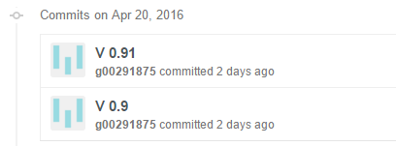

## 3.2 FYP-Android

## C:\year 5\Project Year 5 Documentation\Weekly screenshots\Sprint 8\wk3\fx.PNG4 Toggl Time Logs

## 4.1 Weekly time Log bar chart:

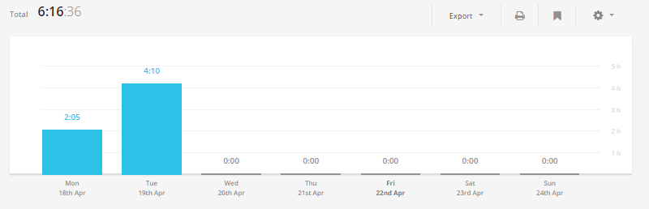

## 4.2 Weekly Time Log:

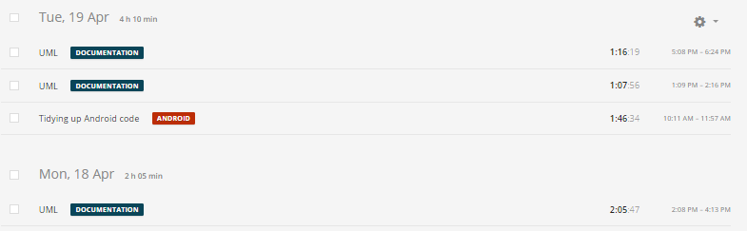

## 4.3Weekly log Pie Charts:

